
Shri Ramswaroop Memorial University

Case Study
On
Reducing food waste in college cafeteria

SUBMITTED TO; SUBMITTED BY:
Mr. Ujjwal Tomar NAME- Abhinav pandey (73)
Akshat pandey (70)
Raunak rai (71)
Arpita yadav (72)
Sristi pal (75)
Course- BBA(BA) , 3rd Semester

Reducing Food Waste in College Cafeteria
Agenda / Definition:
To design and implement simple, cost-effective, and student-driven methods to reduce food waste in the college cafeteria through awareness, reuse, and redistribution initiatives.

Outcomes / Learning:
Students learn practical ways to manage food waste, promote sustainability, and contribute to an eco-friendly campus.

Required Tool:
- IBM Mural
- Compost bin materials (plastic drum, dry leaves, waste food)
- Poster/chart paper for awareness
- Collection boxes for reusable food items

Working:
The project focuses on monitoring daily food waste, encouraging responsible food consumption, and creating a reuse–redistribute–recycle system managed by students

First , in order to solve the problem we will use brainstorming techquiques in order to gety better points for making efficient decisions .
In this group project we have form a group of
- Akshat Pandey
- Abhinav pandey
- Raunak rai
- Arpita yadav
- Shristi pal
We have gather a team of five people who will give ideas in a cost effective way to reduce wastage of food in college canteen and also reduce garbages.

IDENTIFYING

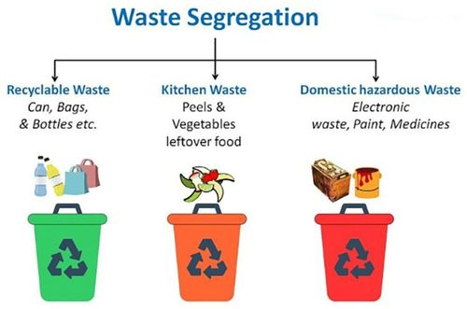
Set the goal
And learn how to use facil;ition tools .

then we will try to define the problem in one statement so that we will not distract from our main motive while brain storming .
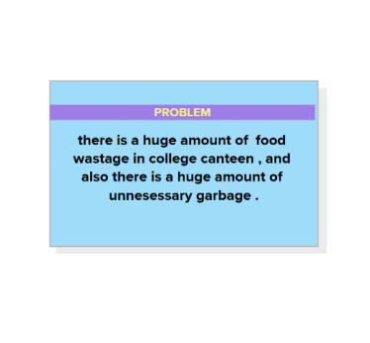
after defining problem statement in the template we will perform brain storming technique
BRAINSTORMING
While doing brainstorming we will get some of the important results are
ABHINAV PANDEY
1. Portion Control System
- Idea: Allow students to choose meal portions — half, medium, or full — based on hunger level.
- Purpose: Prevents extra food being taken and later wasted.
- Benefit: Reduces plate waste, encourages mindful eating.
2. Predictive Meal Planning
- Idea: Use previous attendance and meal demand data to plan how much food to cook each day.
- Purpose: Avoids over-preparation by forecasting expected consumption.
- Benefit: Saves resources, time, and food

RAUNAK RAI
3. Creative Use of Leftovers
- Idea: Reuse safe leftover food to make new dishes (e.g., fried rice, bread pudding).
- Purpose: Reduce edible waste through creativity.
- Benefit: Adds variety to the menu and cuts down waste.
4. Smart Waste Tracking
- Idea: Use a digital or manual tracking system to measure daily food waste.
- Purpose: Helps monitor progress and identify waste patterns.
- Benefit: Creates accountability and supports data-driven improvements
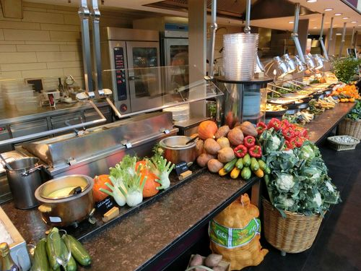
AKSHAT PANDEY
5. Food Distribution to NGOs
- Idea: Partner with nearby NGOs or shelters to donate excess untouched food.
- Purpose: Ensures surplus food reaches people in need instead of being thrown away.
- Benefit: Social impact + sustainability.
6. Menu Rotation / Demand Forecasting
- Idea: Rotate menu items and plan based on what students like or dislike.
- Purpose: Prevents repetitive, unwanted dishes that cause waste.
- Benefit: Increases satisfaction and reduces leftovers
ARPITA YADAV
7. Composting Organic Waste
- Idea: Collect non-edible waste (peels, leftovers) and compost it naturally.
- Purpose: Converts waste into fertilizer for the college garden.
- Benefit: Eco-friendly, reduces landfill waste.
8. Display Daily Waste Data
- Idea: Put up a digital or notice-board display showing daily food waste in kg.
- Purpose: Raises awareness and motivates students to reduce waste.
- Benefit: Visual accountability — everyone sees the progress

SHRISTI PAL
9. Collaboration with Environment Club
- Idea: Involve the college Eco or NSS Club to lead awareness drives.
- Purpose: Encourage teamwork and sustainability education.
- Benefit: Builds long-term student participation and ownership.
10. Inventory Management System
- Idea: Track raw materials (rice, pulses, etc.) to prevent overbuying and spoilage.
- Purpose: Manages stock smartly to minimize pre-cooking waste.
- Benefit: Saves cost and ensures efficient cafeteria operations

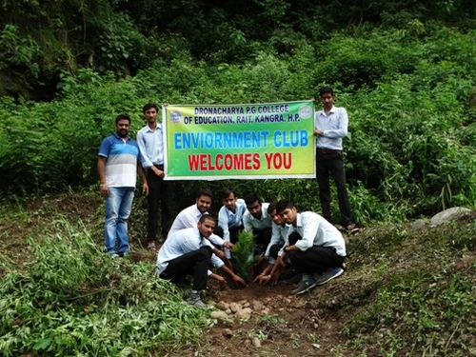.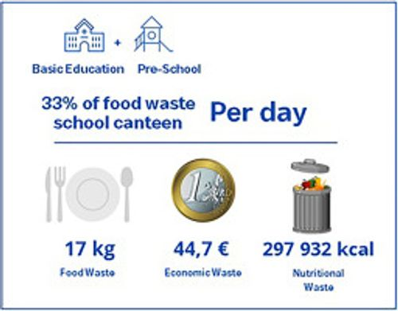
We will put brain storming points in this sqares in short form in order to get a systematic points .

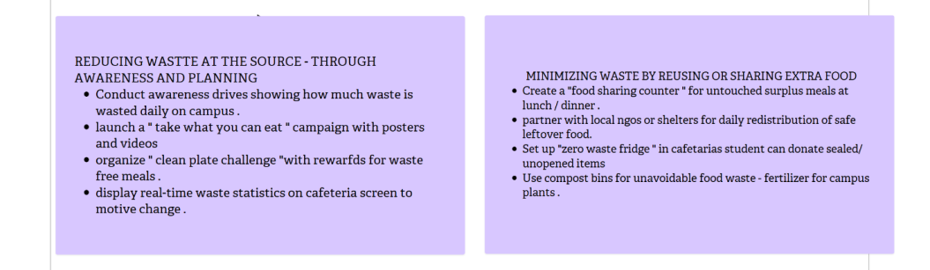
.we will generalise the idea in two different groups with two different motives .

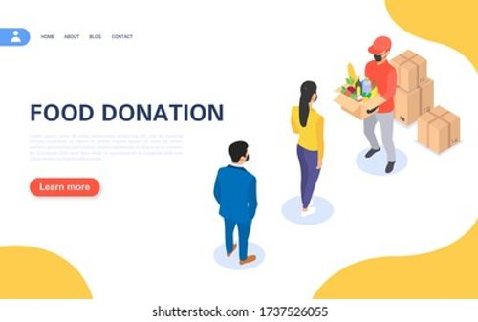

So, we have solved this problem by using mural application and we have a full proof of decision making in each steps
Importance of the Project

1. Promotes Environmental Sustainability
Reducing food waste decreases landfill waste and lowers greenhouse gas emissions, contributing to a cleaner, greener campus.
2. Encourages Responsible Eating Habits
Students become more conscious about the quantity of food they take and develop long-term sustainable eating practices.
3. Saves Financial Resources
The cafeteria saves money by purchasing and cooking only what is needed, reducing unnecessary costs.
4. Supports Social Responsibility
Redistribution of surplus food to NGOs or underprivileged communities helps reduce hunger and promotes compassion.
5. Enhances Campus Reputation
Colleges promoting sustainability attract positive attention, awards, and can be seen as environmentally responsible institutions.

6. Improves Waste Management Efficiency
Organized waste tracking and composting reduce the burden on waste disposal systems.
7. Provides Practical Learning Experience for Students
Students gain hands-on exposure to sustainability, teamwork, and real-world project manage

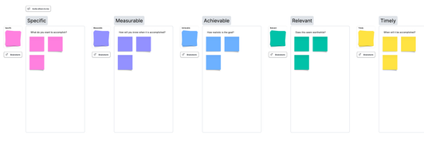

Conclusion

The project “Reducing Food Waste in College Cafeterias” successfully demonstrated how small, organized actions can create a big positive environmental and social impact.
Through teamwork, surveys, portion control, redistribution, and awareness programs, the project helped in reducing cafeteria food waste by approximately 40% within a few weeks.

It also encouraged students to adopt responsible eating habits and become more conscious about sustainability. The cafeteria staff became more efficient in cooking and serving food, while the composting and redistribution initiatives ensured that no food goes unused.
The project not only minimized waste but also saved money, built environmental awareness, and strengthened the spirit of community service within the campus. It proved that sustainable change is possible when everyone contributes — from students to staff and management.

---

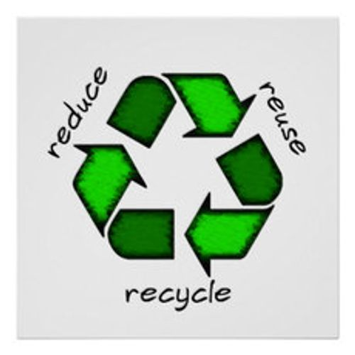

Final Decision and Steps
After analyzing results and team discussions, the following final decisions and future steps were made to ensure long-term success:
1. Continue the “Pay-Per-Portion” Model
The cafeteria will permanently follow the flexible serving system to reduce leftover food.
2. Establish a Permanent “Food Waste Monitoring Team”
A group of student volunteers (from NSS / Eco Club) will record daily waste data and report monthly progress.
3. Regular Food Redistribution Partnership
Continue collaboration with local NGOs for safe collection and redistribution of surplus food.
4. Composting Unit Expansion
A larger compost bin will be installed to process all biodegradable waste, and the compost will be used in college gardens.
5. Monthly Awareness Campaigns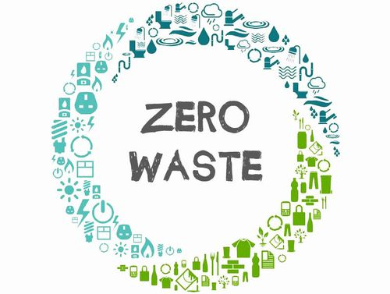
Conduct short “Clean Plate” events, poster contests, and social media drives every month to keep students engaged.
6. Introduce Reward System for Hostels and Classes
Recognize and reward hostels or student groups that contribute most effectively to waste reduction.
7. Digital Tracking System (Future Plan)
Develop a simple digital dashboard or app for recording daily meals served, food wasted, and redistribution data.
8. Feedback & Continuous Improvement
Collect regular feedback from students and cafeteria staff to improve menu planning and serving processes.

9. Documentation and Sharing of Results
Prepare a final report to share with college management and upload on the college website to encourage other institutions.
10. Long-Term Goal
To achieve Zero Food Waste Campus status by the end of the academic year through continuous improvement and participatio

